850,000 visitors for The Tall Ships Races

The arrival of sailing ships and the Bollekesfeest Festival made for a fantastic weekend in the city
Dozens of sailing ships are leaving Antwerp today for Aalborg in Denmark for the second race of The Tall Ships Races, which called at Antwerp for the seventh time. Some 40 ships were moored for four days in the docks around the MAS, at Kattendijkdok and at the Scheldt Quays near Het Steen. At the same time, the Bollekesfeest Festival took place on the Grote Markt and Groenplaats. Some 850,000 visitors came to soak up the atmosphere in Antwerp, admire the cathedrals of the sea and enjoy performances, good food and drink during this long weekend of festivities.

It was not only the beautiful ships that attracted crowds. The side activities were popular as well. For example, the traditional Crew Parade took place on Saturday from the Zuiderterras, via the Quays, past the MAS to the Port House. The live concerts at Zaha Hadidplein and Steenplein were also popular. There was a unique fireworks display at three different locations on Saturday, which attracted a lot of spectators. At the MAS, visitors were also able to see innovative and sustainable initiatives of some partners and at Napoleonkaai there was the busy Maritime Market. And a lot of people came to see the numerous performances that took place at the Bollekesfeest Festival.

Mayor Bart De Wever: “These days have been fantastic for Antwerp. The atmosphere of these mighty sailing ships, the sight of the many masts and ropes with our city as a backdrop, fills every Antwerp inhabitant with pride. It is no wonder that so many of them, and a crowd of visitors from elsewhere, came to enjoy this. The link with the Bollekesfeest Festival proved to be a huge success, with a spectacular fireworks display as the icing on the cake. It was a real delight. After two years, this was the popular festival our city deserved. I can hardly wait until the next edition! My thanks to everyone involved in the flawless organisation, because they made me and so many others proud of Antwerp."

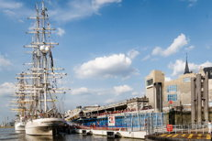 |  | 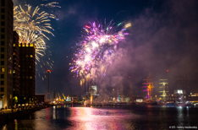 |  | 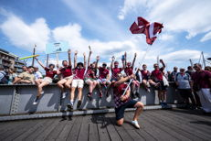 |  | 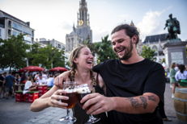

© Jonathan Ramael ; Valery Vasilevskiy (fireworks) ; LUCID (ships on the Scheldt)

Ships leave on Monday

The Tall Ships Races 2022 consists of two races. The first race started on 7 July in Esbjerg (Denmark) and ended in Harlingen (Netherlands). The ships sailed from there to Antwerp and arrived on 22 July. Today, on Monday the 25th, the ships leave for a second race towards Aalborg (Denmark).

The aim of the Races is to generate a crucial positive social impact. They promote mutual understanding between young people from different cultures and countries, and through sailing training offer them personal development and experiences that they will carry with them for life. After an inclusive selection almost one hundred Belgian youngsters will participate, as members of the Antwerp Crew.

2026 and 2030

Antwerp will also be host city for the next two editions of The Tall Ships Races, in 2026 and 2030. As already announced on Friday, the city has been recognised as the very first 'Anchor Port' by organiser STI.

Port alderman Annick De Ridder: "As vice-mayor for the port, I want to restore the ties between the city and the river Scheldt, because the Flemish people should once again be proud of the tradition of shipping and the great prosperity that our port provides. The high number of visitors last weekend proves that there is genuine interest in this. That is why, together with the many other visitors, I am already looking forward to the next edition in 2026, which will again call at Antwerp. We wish the crews a safe journey to Aalborg in Denmark."

You can find all the press info, previous press releases and photographs here: https://tallships.antwerpen.be/en/pers/.

Below, the press can also download a document (only available in Dutch) with extra facts and figures about this record Antwerp edition of The Tall Ships Races.

Weetjes_Cijfers_TSR2022.docx
23 KB

Bart De Wever

Mayor

Annick De Ridder

Alderman for the port

Dirk Delechambre

Spokesman for the City of Antwerp

E-mail  dirk.delechambre@antwerpen.be | Mobiel  +32 475 63 65 65

Gert Ickx

Spokesman for the Port of Antwerp-Bruges

E-mail  gert.ickx@portofantwerpbruges.com | Mobiel  +32 492 15 41 39

Copyright header image: LUCID

